Parallel Collector with the following parameters

-Xms3m -Xmx12m -Xmn1m -XX:PermSize=20M -XX:MaxPermSize=20m -XX:+UseParallelGC 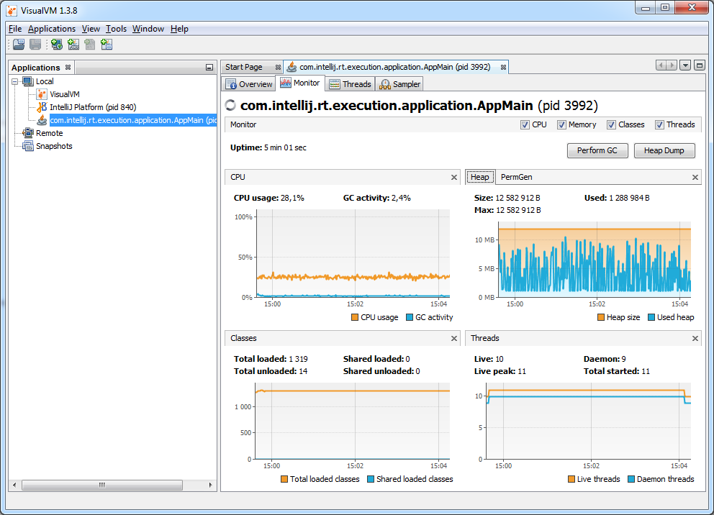

Parallel Old Collector with the following parameters

-Xms9m -Xmx18m -Xmn3m -XX:PermSize=40M -XX:MaxPermSize=40m -XX:+UseParallelOldGC

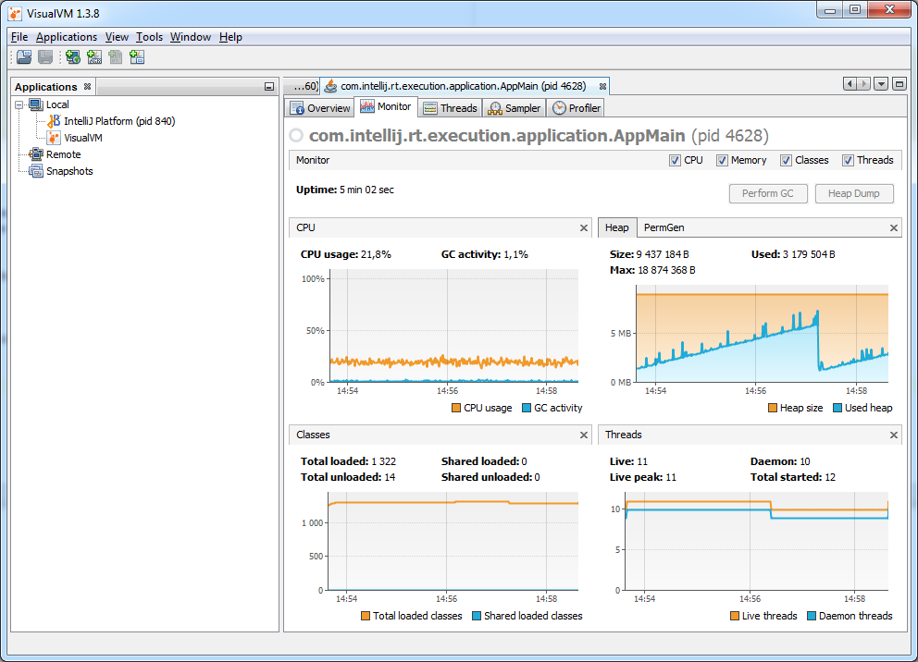

Concurrent Mark Sweep (CMS) Collector with 2 Parallel CMS Threads with the following parameters

-Xms6m -Xmx18m -Xmn2m -XX:PermSize=20M -XX:MaxPermSize=30m -XX:+UseConcMarkSweepGC -XX:ParallelCMSThreads=2

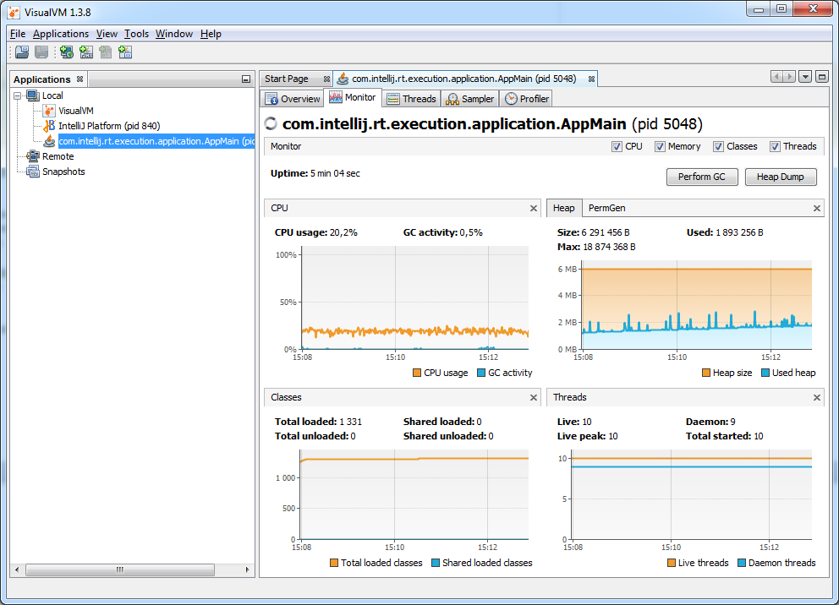

G1 Garbage Collector with the following parameters

-Xms4m -Xmx16m -Xmn2m -XX:PermSize=12M -XX:MaxPermSize=18m -XX:+UseG1GC

